PROJECT REPORT TEMPLATE

INTRODUCTION
1.1OVERVIEW
MY PROJECT IS DREAM HOME REALITY I MADE THESE Project with my team members it is easy to handle and carry accounts
1.2 PURPOSE
IT IS VERY useful to handle accounts and proper maintain of all detail to see business result final output we achived

2. PROBLEM DEFINITIONS & DESIGN THINKING
2.1 EMPATHY MAP

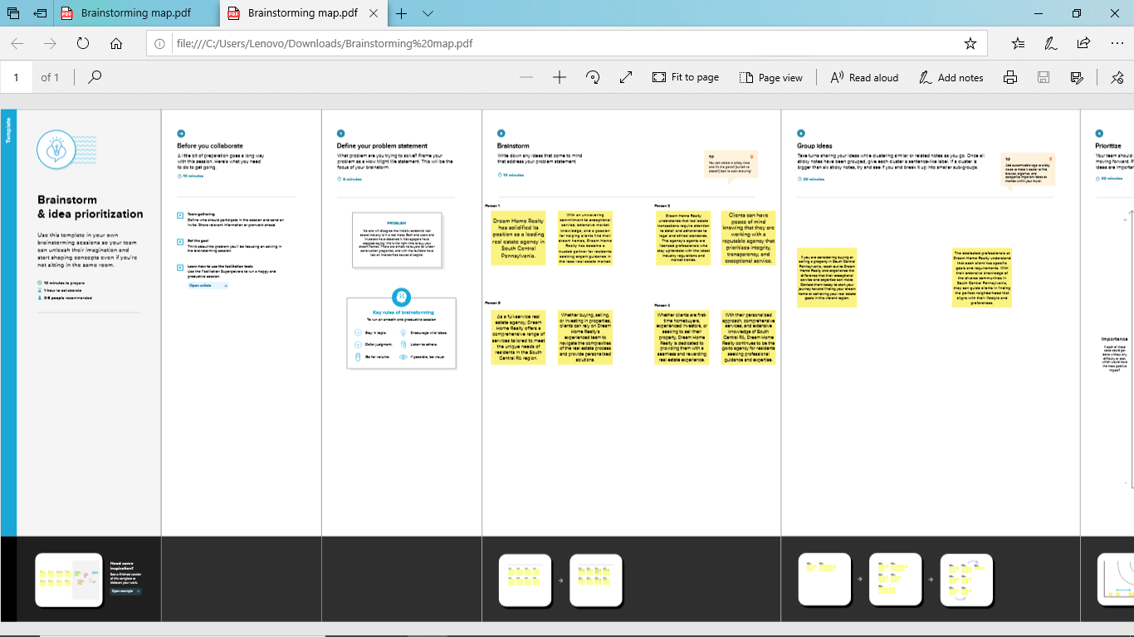
2.2 BRAIN STORM MAP

4. ADVANTAGE & DISADVANTAGEI

IT IS VEY USEFUL TO REFER OF ACCOUNT AND HANDLE IN Proper manner proper output given
It reduce manual work and security
5.CONCLUSION
IT IMPROVE team efficiency and to get good result
6. FUTURE SCOPE
IT will get good result in future

